**Phase 8: Data Management & Deployment**

This phase ensures your Salesforce org’s data is **imported, cleaned, backed up, and deployed** properly across environments (Developer Org, Sandbox, Production).

**1. Data Import Wizard**

* **What it is:** A built-in Salesforce tool to import data (up to 50,000 records).
* **How to Use:**
  1. Setup → **Data Import Wizard**.
  2. Choose an object (e.g., **Leads, Accounts, or Custom Object** like Leave_Request__c).
  3. Upload a CSV file.
  4. Map CSV columns to Salesforce fields.
  5. Click **Start Import**.
* **Use Case in Project:** Import employee records or leave history into your custom objects.

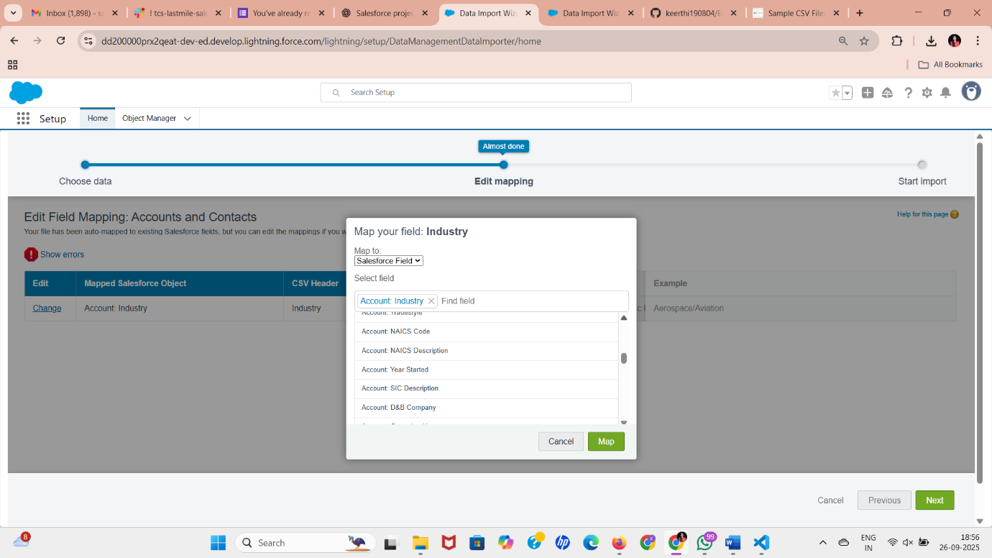

**2. Data Loader**

* **What it is:** A client application (desktop tool) to handle large data (up to 5 million records).
* **How to Use:**
  1. Download **Data Loader** from Salesforce Setup → Data Loader.
  2. Log in with Salesforce credentials.
  3. Choose Insert, Update, Upsert, Delete, or Export.
  4. Provide CSV + field mapping.
* **Use Case:** Bulk load employee leave balances, update statuses, or export for analysis.  
  *(Note: Not directly in Developer Console, needs external tool.)*

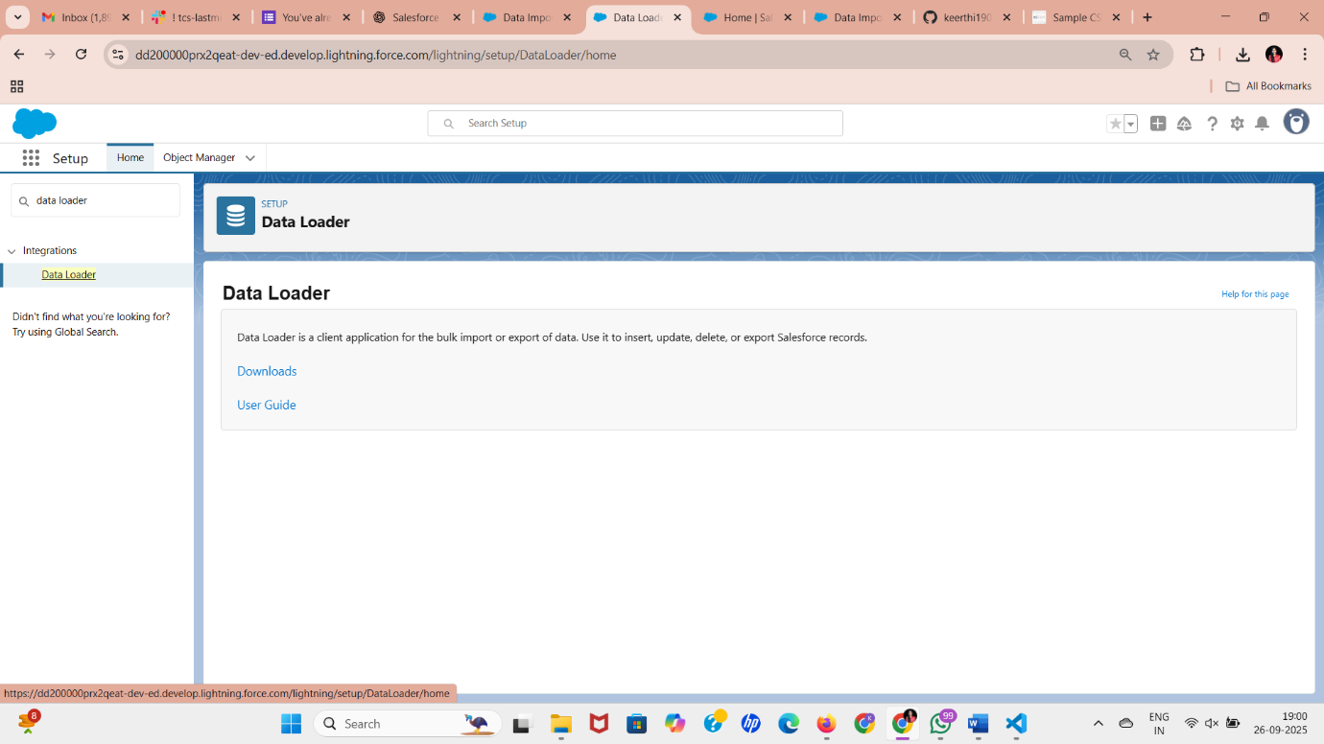

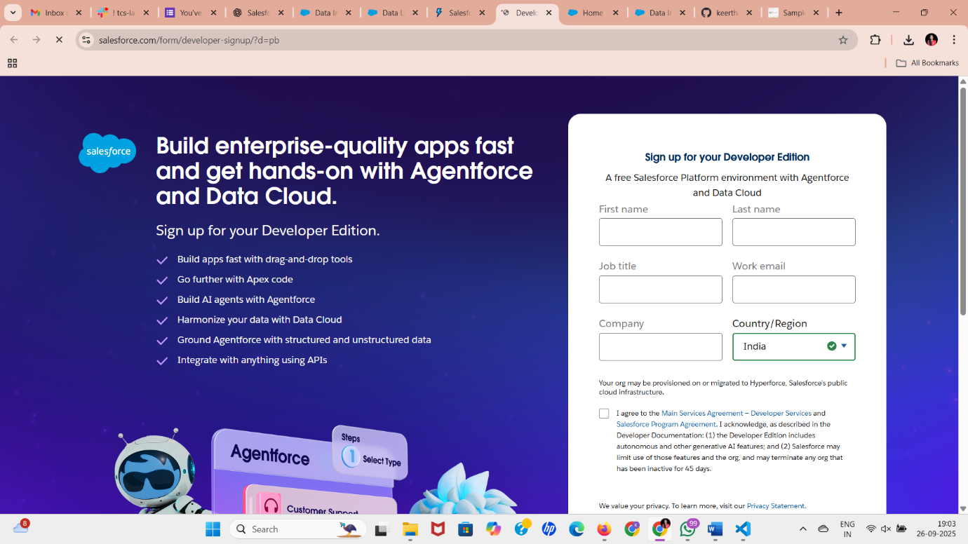

**3. Duplicate Rules**

* **What it is:** Prevents duplicate records during data entry.
* **How to Set:**
  1. Setup → **Duplicate Rules**.
  2. Create Rule → Object = Employee (custom or standard).
  3. Matching Rule = Email or Employee ID must be unique.
  4. Choose Action = **Block or Allow but Report**.
* **Use Case:** Prevent duplicate Employee or Leave Request records.

**4. Data Export & Backup**

* **What it is:** Export org data for backup.
* **How to Do:**
  1. Setup → **Data Export**.
  2. Schedule Weekly/Monthly export.
  3. Choose objects → Download ZIP with CSV files.
* **Use Case:** Backup Leave Requests and Employee Data for HR compliance.

**5. Change Sets**

* **What it is:** Point-and-click tool to deploy metadata (not data) from one Salesforce org to another (e.g., Sandbox → Production).
* **How to Use:**
  1. Setup → **Outbound Change Sets**.
  2. Create Change Set → Add Components (Objects, Fields, Apex Classes).
  3. Upload to Target Org → Go to Target Org → **Inbound Change Sets** → Deploy.
* **Use Case:** Move custom objects, validation rules, Apex classes from Dev Org to another Org.

**6. Unmanaged vs Managed Packages**

* **Unmanaged Package:**
  + Used for sharing **open-source projects**.
  + Components editable after installation.
  + Good for your **Leave Management Project** to share with friends.
* **Managed Package:**
  + Used by ISVs for AppExchange.
  + Components **locked** after publishing.
  + Supports licensing, versioning, upgrades.

**7. ANT Migration Tool**

* **What it is:** Command-line tool using Apache ANT + Metadata API.
* **How to Use:**
  1. Install Apache ANT.
  2. Create build.xml and package.xml.
  3. Run commands like ant retrieve or ant deploy.
* **Use Case:** Automate deployments for advanced users.  
  *(Not in Developer Console, but useful for CI/CD pipelines.)*

**8. VS Code & SFDX**

* **What it is:** Developer-friendly deployment & source control.
* **Steps:**
  1. Install **VS Code + Salesforce Extensions**.
  2. Authenticate to Dev Org → sfdx auth:web:login.
  3. Retrieve Metadata → sfdx force:source:pull.
  4. Deploy Metadata → sfdx force:source:deploy.
  5. Connect VS Code to GitHub → push your project repo.
* **Use Case:** Store your Leave Management project on GitHub, deploy between Dev & Sandbox.

**✅ What You Can Do in Developer Org / Console**

* **Data Import Wizard** → Import your CSV test data.
* **Duplicate Rules** → Stop duplicate Employee IDs.
* **Data Export** → Backup your test data.
* **Change Sets** → If you have 2 Salesforce Orgs, move your project.
* **Unmanaged Package** → Package your project and share.
* **Apex in Developer Console** → Write test scripts to insert/export data. Example:

// Insert sample employee

Employee_API__c emp = new Employee_API__c(

Name = 'John Doe',

Username__c = 'jdoe',

Email__c = 'john.doe@example.com'

);

insert emp;